TASK-2

TITLE: Develop a simple synchronous RAM module with read and write operations
OBJECTIVE: To design and simulate a simple synchronous RAM using Verilog HDL that performs read and write operations based on clock pulse
SOFTWARE USED: vivado
THEORY: RAM (Random Access Memory) is a memory device used to store data temporarily. In synchronous RAM, all operations happen only at the active edge of the clock signal.
Operations:
Write Operation: Data is stored in memory when Write Enable (we) = 1.
Read Operation: Stored data is sent to output when Write Enable (we) = 0.
Features:
16 memory locations
Each location stores 8-bit data
Controlled by clock signal
CODE:
VERILOG CODE FOR RAM:
`timescale 1ns / 1ps
///ram design
module task_2(
input clk,
input we, // Write Enable
input [3:0] addr, // 16 locations
input [7:0] din, // Input Data
output reg [7:0] dout // Output Data
):
reg [7:0] mem [15:0];
always @(posedge clk)
begin
if(we)
mem[addr] <= din; // Write operation
else
dout <= mem[addr]; // Read operation
end
endmodule
TESTBENCH FOR THAT VERILOG CODE:
`timescale 1ns / 1ps ///testbench for ram design
module task_2_tb;
reg clk;
reg we;
reg [3:0] addr;
reg [7:0] din;
wire [7:0] dout;
task_2 uut(
.clk(clk),
.we(we),
.addr(addr),
.din(din),
.dout(dout));
always #5 clk = ~clk;
initial begin
clk = 0;
// Write 55 at address 2
we = 1; addr = 4'd2; din = 8'd55;
#10;
// Write 99 at address 5
we = 1; addr = 4'd5; din = 8'd99;
#10;
// Read address 2
we = 0; addr = 4'd2;
#10;
// Read address 5
we = 0; addr = 4'd5;
#10;
$stop;
end
endmodule
SIMULATION RESULT:
Write cycles:
Data 37 written into address 2
Data 63 written into address 5
Read cycles:
Address 2 output = 37
Address 5 output = 63
The waveform confirms successful read and write operations
TRUTH TABLE:
We | Operation
1 | Write
0 | Read

OUTPUT OBSERVATION TABLE:
Time(ns) | we | Address | Data in | Data out
10 | 1 | 2 | 37 | XX
20 | 1 | 5 | 63 | XX
30 | 0 | 2 | -- | 37
40 | 0 | 5 | -- | 63

PRACTICAL OUTPUT:
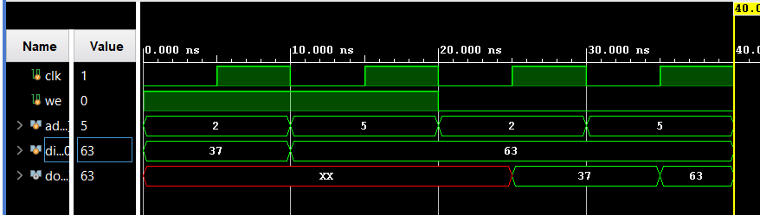

CONCLUSION:
A synchronous RAM module was successfully designed and simulated using Verilog HDL. The RAM correctly stored input data during write mode and produced stored data during read mode.

